**LAB 01 TASKS**

**Question #01**) **Print the below patterns?**

**\*\*\*\*\*\*\*\*\*\*\*\***

**********

*****

**

Xx

Xxxxxxxx

Xxxxxxxxxxxx

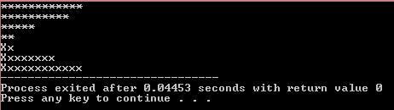**Source Code: Ouput:**

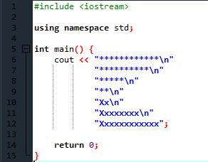

**Question #02**) **Make your CV that include your Name, Father’s Name, CNIC, Qualification, Semester, CGPA etc.? Print each line separately using “\n” and “endl”? Use comments also.**

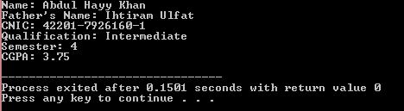**Source Code: Ouput:**

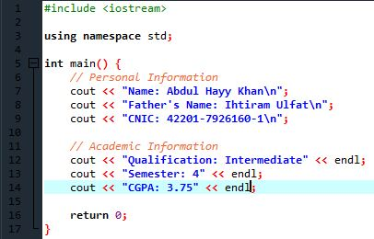

**Question #03) Prepare list of available header files and their respective functions(Memorize them)**

**1. <iostream>**

* **Functions**:
  + std::cout: Output stream for printing to the console.
  + std::cin: Input stream for reading from the console.
  + std::cerr: Output stream for errors.
  + std::clog: Output stream for logging messages.
  + std::cerr: Output stream for errors.

**2. <iomanip>**

* **Functions**:
  + std::setprecision(): Sets the decimal precision for floating-point output.
  + std::setw(): Sets the width of the next output field.
  + std::fixed: Formats floating-point numbers in fixed-point notation.
  + std::scientific: Formats floating-point numbers in scientific notation.

**3. <string>**

* **Functions**:
  + std::string: Class for manipulating strings.
  + std::getline(): Reads a line from an input stream into a string.
  + string::size(): Returns the length of the string.
  + string::substr(): Returns a substring.

**4. <vector>**

* **Functions**:
  + std::vector: Dynamic array class.
  + vector::push_back(): Adds an element to the end.
  + vector::pop_back(): Removes the last element.
  + vector::size(): Returns the number of elements.

**5. <algorithm>**

* **Functions**:
  + std::sort(): Sorts a range of elements.
  + std::reverse(): Reverses the order of elements.
  + std::find(): Finds an element in a range.
  + std::accumulate(): Computes the sum of elements.

**6. <cmath>**

* **Functions**:
  + std::sqrt(): Returns the square root.
  + std::pow(): Raises a number to a power.
  + std::sin(), std::cos(), std::tan(): Trigonometric functions.
  + std::log(): Computes the natural logarithm.

**7. <cstdlib>**

* **Functions**:
  + std::atoi(): Converts a string to an integer.
  + std::atof(): Converts a string to a float.
  + std::rand(): Generates a random number.
  + std::srand(): Seeds the random number generator.

**8. <ctime>**

* **Functions**:
  + std::time(): Returns the current time.
  + std::difftime(): Computes the difference between two time values.
  + std::ctime(): Converts time to a string representation.

**9. <fstream>**

* **Functions**:
  + std::ifstream: Input file stream for reading from files.
  + std::ofstream: Output file stream for writing to files.
  + std::fstream: Input/Output file stream for both reading and writing.
  + fstream::open(): Opens a file.
  + fstream::close(): Closes a file.

**10. <map>**

* **Functions**:
  + std::map: Associative container that contains key-value pairs.
  + map::insert(): Inserts an element.
  + map::find(): Finds an element by key.
  + map::erase(): Removes an element by key.

**11. <set>**

* **Functions**:
  + std::set: Container that stores unique elements.
  + set::insert(): Inserts an element.
  + set::find(): Finds an element.
  + set::erase(): Removes an element.

**12. <unordered_map>**

* **Functions**:
  + std::unordered_map: Unordered associative container that contains key-value pairs.
  + unordered_map::insert(): Inserts an element.
  + unordered_map::find(): Finds an element by key.
  + unordered_map::erase(): Removes an element by key.

**13. <thread>**

* **Functions**:
  + std::thread: Class for creating and managing threads.
  + thread::join(): Waits for a thread to finish.
  + thread::detach(): Detaches a thread from the main thread.

**14. <mutex>**

* **Functions**:
  + std::mutex: Class for mutual exclusion to prevent data races.
  + mutex::lock(): Locks the mutex.
  + mutex::unlock(): Unlocks the mutex.

**15. <condition_variable>**

* **Functions**:
  + std::condition_variable: Class for blocking a thread until notified.
  + condition_variable::wait(): Blocks the current thread.
  + condition_variable::notify_one(): Unblocks one waiting thread.
  + condition_variable::notify_all(): Unblocks all waiting threads.

This list covers some of the most commonly used header files in C++. Each header file serves specific purposes and provides functions and classes that facilitate various programming tasks.

**Question #04) Describe phases of compilation.**

The compilation process in C++ consists of several distinct phases, each of which transforms the source code into an executable program. Here’s a breakdown of the main phases:

**1. Preprocessing**

* **Description**: This is the first phase where the preprocessor handles directives (commands) that begin with #, such as #include, #define, and #ifdef.
* **Actions**:
  + **File Inclusion**: Replaces #include directives with the contents of the specified files (header files).
  + **Macro Expansion**: Expands macros defined by #define.
  + **Conditional Compilation**: Evaluates conditional directives and includes or excludes portions of code based on specified conditions.

**2. Compilation**

* **Description**: In this phase, the preprocessed code is translated into assembly code specific to the target architecture.
* **Actions**:
  + **Syntax and Semantic Analysis**: Checks the code for syntax errors and verifies that it follows the rules of the language.
  + **Intermediate Code Generation**: Converts the high-level code into an intermediate representation, which is easier to manipulate.
  + **Optimization**: May apply optimizations to improve performance and reduce resource usage (though this may vary depending on the compiler settings).

**3. Assembly**

* **Description**: The assembly code generated during the compilation phase is translated into machine code (object code).
* **Actions**:
  + The assembler converts the assembly language instructions into binary format that the computer's processor can execute.
  + This results in an object file, typically with a .o or .obj extension, containing machine code but not yet a complete executable.

**4. Linking**

* **Description**: The final phase where the object files generated from multiple source files are combined to create the final executable program.
* **Actions**:
  + **Symbol Resolution**: Resolves references to functions and variables between different object files.
  + **Library Linking**: Links against system libraries or other libraries specified by the programmer (e.g., standard libraries).
  + **Executable Generation**: Produces a final executable file (usually with an .exe extension on Windows or no extension on Unix-like systems).

**Question #05) Describe different types of computer languages (at least 8).**

**1. High-Level Languages**

* **Description**: These languages are designed to be easy for humans to read and write. They abstract away the complexities of the underlying hardware.
* **Examples**: Python, Java, C++, and Ruby.
* **Features**: Use of natural language elements, strong abstraction, and platform independence.

**2. Low-Level Languages**

* **Description**: Low-level languages provide little abstraction from a computer's instruction set architecture. They are closely related to machine code.
* **Examples**: Assembly language.
* **Features**: Direct manipulation of hardware, higher performance, and greater control, but more complex and less portable.

**3. Machine Language**

* **Description**: This is the lowest level of programming language, consisting of binary code that the computer's CPU can execute directly.
* **Examples**: Binary code (e.g., 01010100).
* **Features**: Fast execution and no need for translation, but difficult for humans to read and write.

**4. Scripting Languages**

* **Description**: Scripting languages are typically interpreted languages used for automating tasks and integrating systems.
* **Examples**: JavaScript, Python, Perl, and Bash.
* **Features**: Dynamic typing, ease of use, and often built for specific environments (like web browsers).

**5. Functional Languages**

* **Description**: These languages treat computation as the evaluation of mathematical functions and avoid changing state or mutable data.
* **Examples**: Haskell, Lisp, and Erlang.
* **Features**: First-class functions, immutability, and a focus on function application.

**6. Object-Oriented Languages**

* **Description**: These languages are based on the concept of "objects," which can contain data and code that manipulates that data.
* **Examples**: Java, C++, and C#.
* **Features**: Encapsulation, inheritance, and polymorphism, which help organize code and promote reuse.

**7. Markup Languages**

* **Description**: Markup languages are designed for the presentation of data rather than for computation.
* **Examples**: HTML (HyperText Markup Language), XML (eXtensible Markup Language), and Markdown.
* **Features**: Use of tags to define structure, primarily used for document formatting and data interchange.

**8. Domain-Specific Languages (DSL)**

* **Description**: DSLs are specialized languages designed for a specific domain or problem space.
* **Examples**: SQL (Structured Query Language for databases), VHDL (for hardware description), and CSS (Cascading Style Sheets for web design).
* **Features**: Tailored syntax and semantics that cater specifically to particular types of tasks.

**9. Procedural Languages**

* **Description**: These languages follow a set of procedures or routines to perform tasks.
* **Examples**: C, Fortran, and Pascal.
* **Features**: Emphasize a sequence of actions or commands, using constructs like loops, conditionals, and subroutines.

**10. Concurrent Languages**

* **Description**: Designed for concurrent programming, allowing multiple processes to run simultaneously.
* **Examples**: Go, Erlang, and Ada.
* **Features**: Built-in support for multi-threading and asynchronous operations